Nama : Abdi Akhsanul Afkar

NIM : 18090048

Kelas : 5C

PRAKTEK W6

1. Code

database.php - application/config

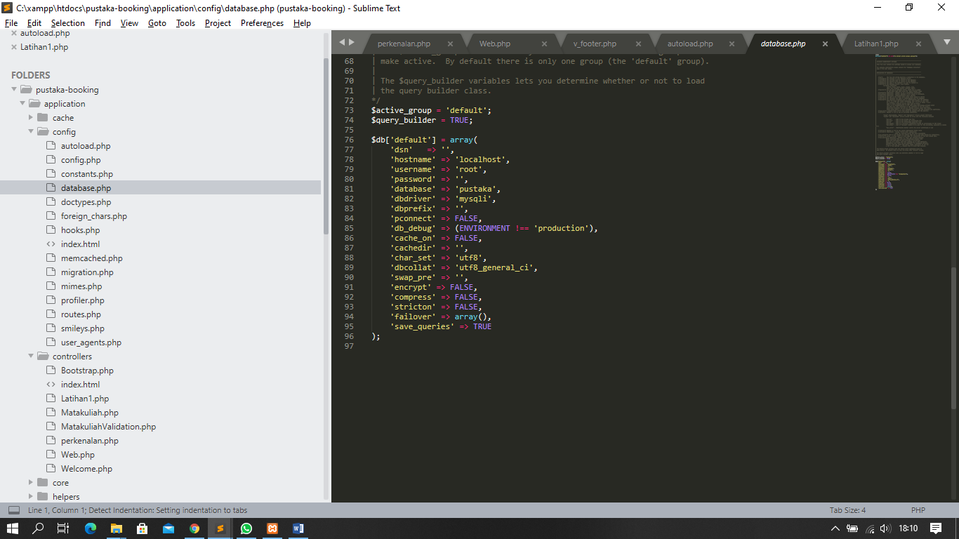

modelUser.php - application/model

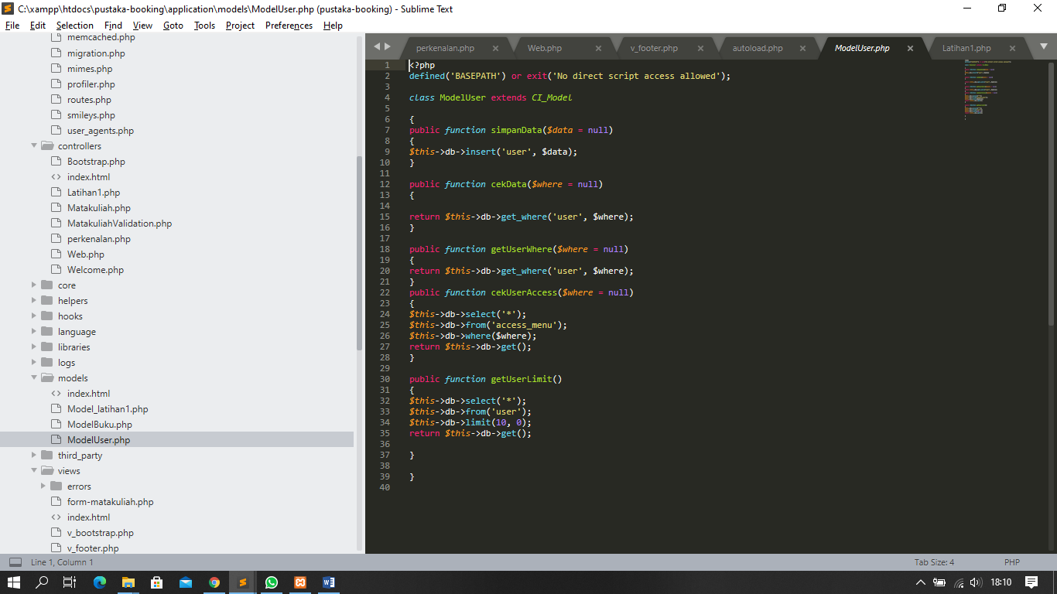

modelBuku.php application/model

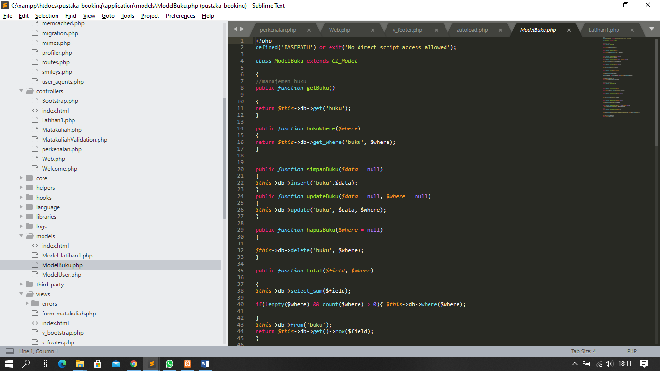

1. Membuat
   1. Database pustaka
   2. table user
   3. table buku
   4. table role
   5. table katogori

